Roll no: 241701021

Computer Networks Exercise 2

Aim:
To connect two Hubs through copper cross over and connect end devices with hub.

Ball Diagram:

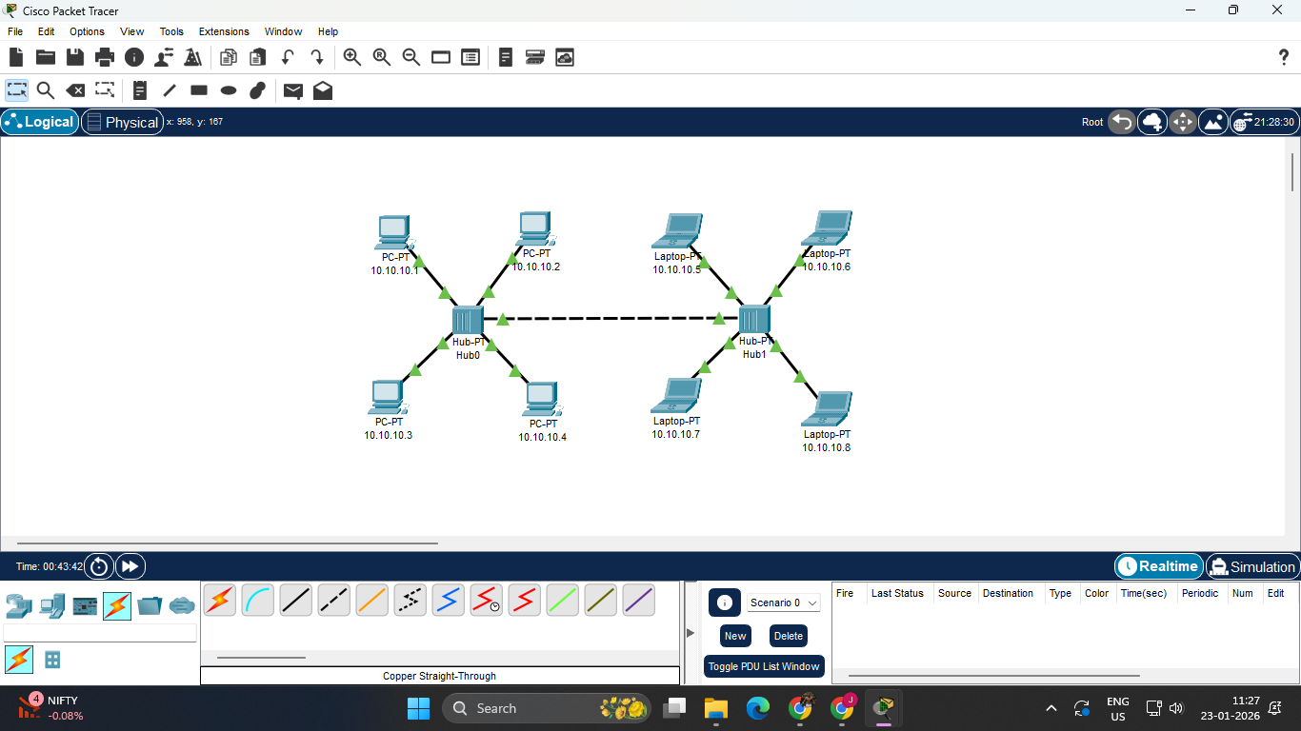

Components Required:
- 2 Hub
- 4 Desktop
- 1 Copper cross over
- 8 Copper straight through
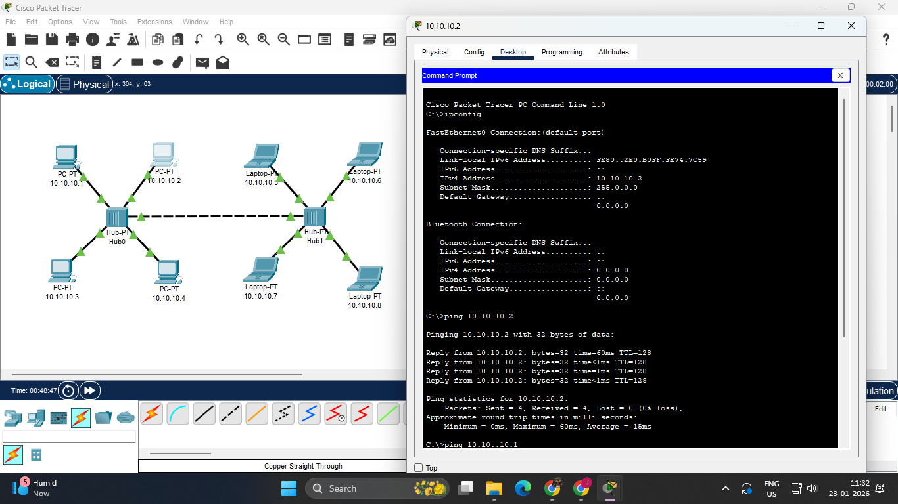

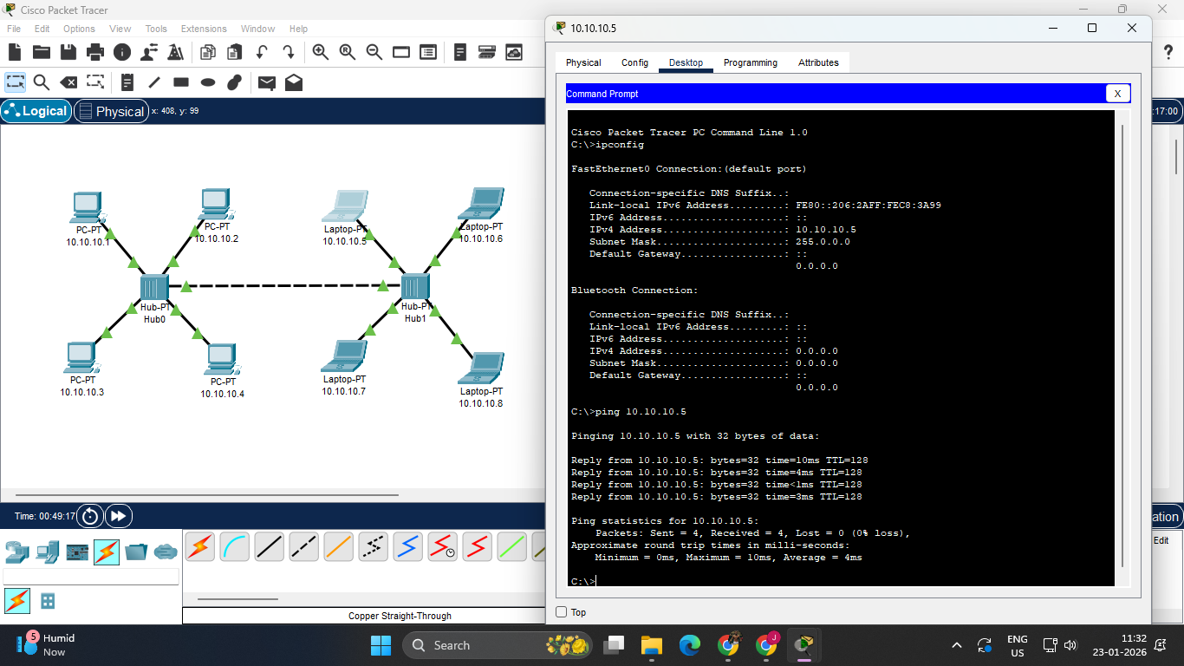
Procedure:

- Place the 2 PT Hub in the middle of the screen from the components provided.
- Place 8 End Devices around the PT Hub. It may be either a PC or a Laptop.
- Connect the 2 PT Hub through Copper cross over.
- Connect the End Devices to the PT Hub using Copper Straight-Through wires through Fast Ethernet.
- Click on each of the End Devices, go to Desktop and set the respective IP addresses in the IPv4 address tab.
- Rename the End Devices as per their respective IP addresses.
- Now, we can click on any End Device, go to Command Prompt in the Desktop tab and type in commands to view the ip configuration, to ping, etc.

Result:
Thus connection two Hubs through copper cross over and connect end devices with hub has been executed successfully.

